**21CSS303T DATA SCIENCE**

**Assignment – III**

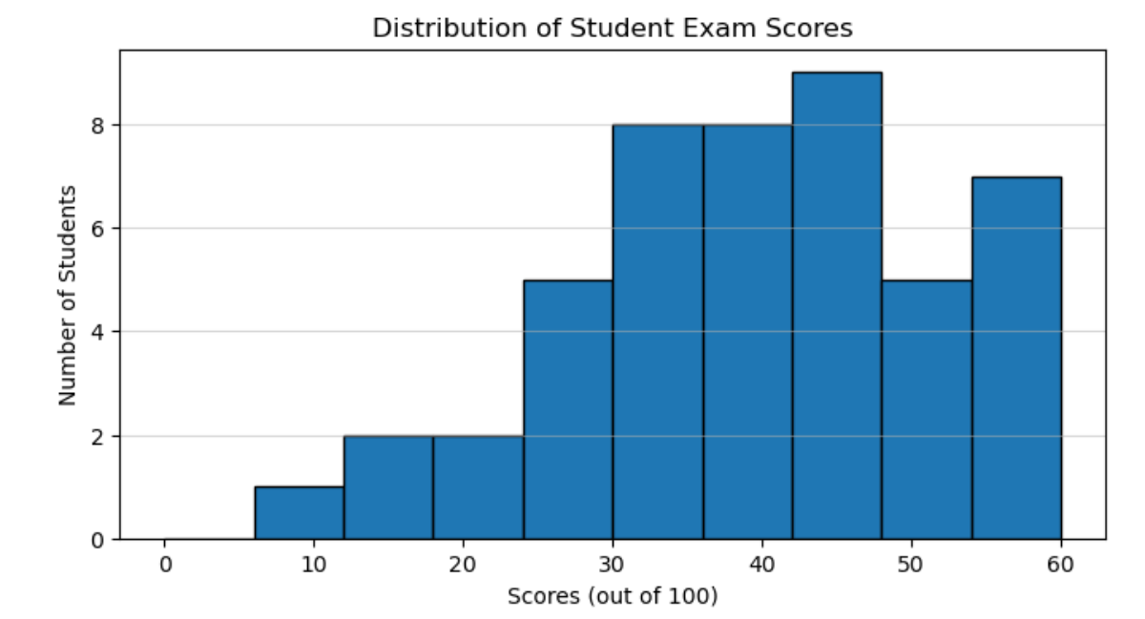

* If the passing score is 30, how many students failed?
* Estimate the total number of students represented in the histogram.
* What type of distribution does this histogram represent?

1. Write a Python program to plot a **3D surface** using Matplotlib.

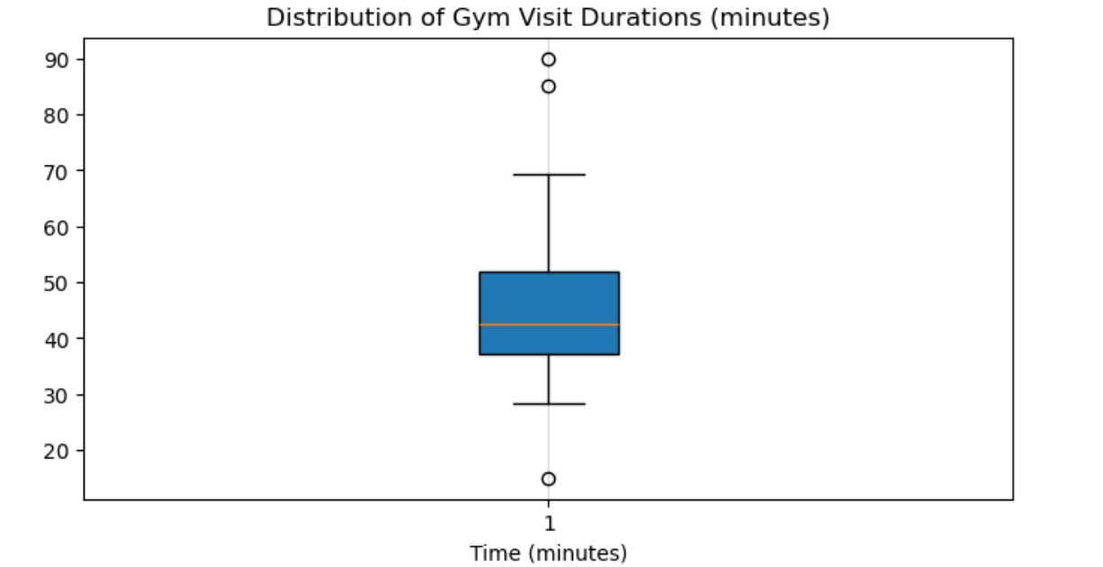

* What is the median gym visit duration?
* How many outliers are shown in the plot?
* 50% of members stayed between Q1 and Q3. Ste True or False.
* If a visit lasts 100 minutes, would it be an outlier? Justify.

1. What are the main uses of 3D plots in data visualization?
2. *import seaborn as sns*

*import pandas as pd*

*import numpy as np*

*np.random.seed(42)*

*data = pd.DataFrame({*

*'Age': np.random.randint(20, 70, 100),*

*'Income': np.random.normal(50000, 15000, 100).astype(int),*

*'Spending': np.random.normal(0.8, 0.2, 100) * np.random.normal(50000, 15000, 100).astype(int), 'Savings': np.random.uniform(1000, 20000, 100).astype(int)*

*})*

* Write python code to create the Pair plot
* If Savings vs. Age scatter plot had a negative slope, suggest solution.
* If Age vs. Spending scatter plot shows no clear pattern. Interpret the relationship.

1. What are the different types of plots available in **Seaborn**? Briefly explain at least four with examples.
2. You are working with a company’s monthly sales data of three products over one year. The data contains months on the x-axis and sales values on the y-axis.

* Create a **line plot** for the three products on the same figure using **different styles, colors, and markers**. Explain how you control line properties.
* Demonstrate how to create **subplots** to show each product’s performance in a separate panel, and **annotate** the peak sales point in each subplot.
* Add a **title, axis labels, legend, and grid** to your main plot and explain how these enhance readability.

**Date of Submission: 05.05.2025**